**Nervous control Chapter 7.1**

**NERVES**  p. 225-226

**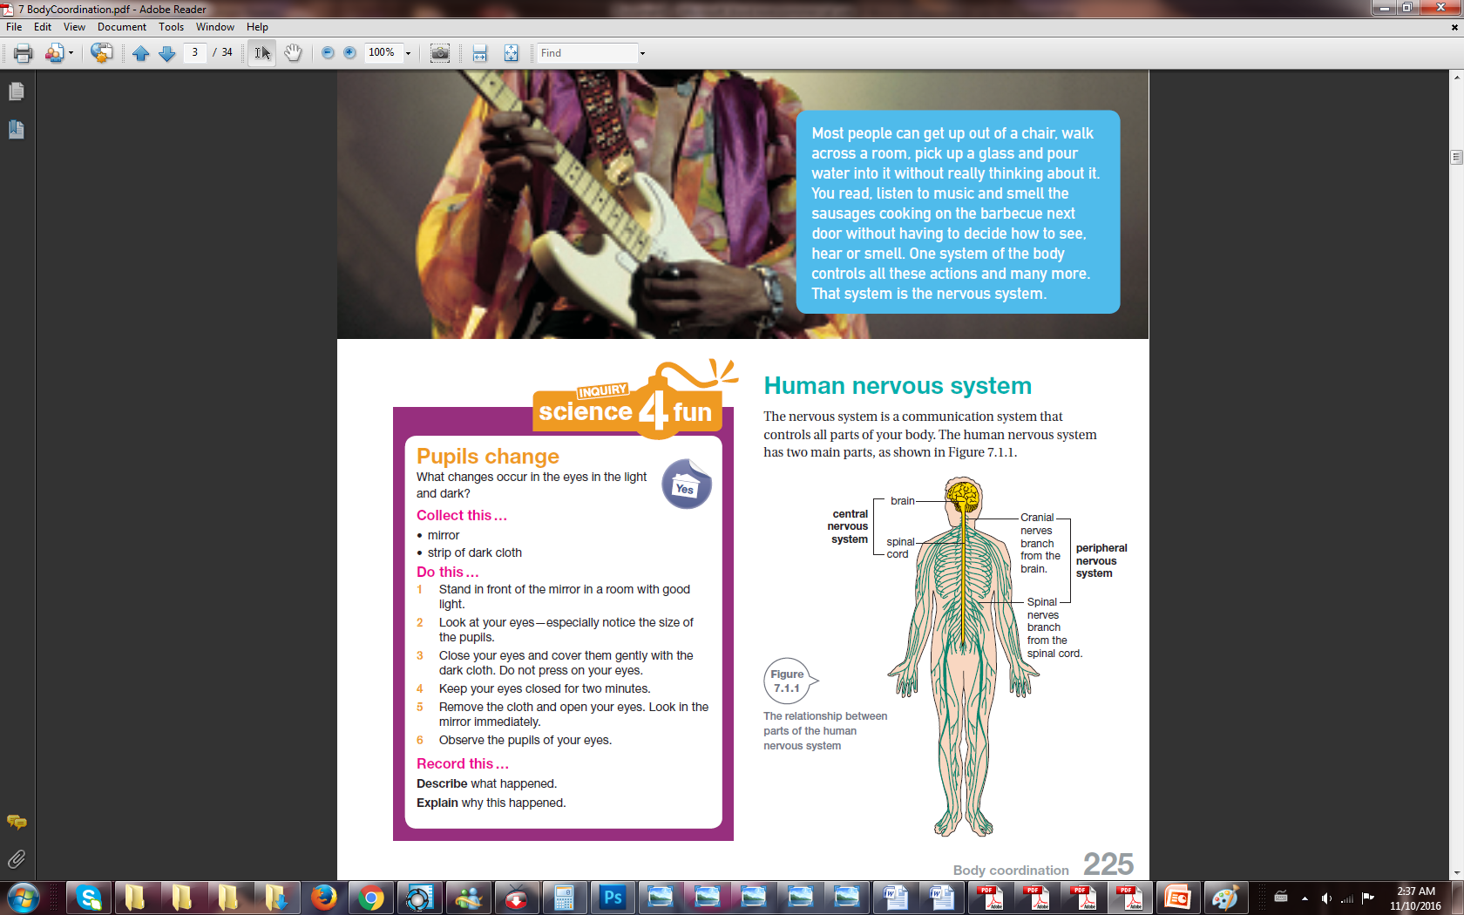*Nervous system :*** A **communication** system that controls **all** parts of your **body**.

***CENTRAL***

**nervous system** (CNS)

- brain

- spinal cord

***PERIPHERAL***

**nervous system** (PNS)

- made up of the nerves that carry messages **to** and **from** the **CNS** and **other parts** of your **body**.

**Nerves** Neurones bundled together.

***Neurones*** the structures that nerve impulses are sent along to deliver these messages.

**Nerve impulses:** an electrical message carried by a nerve cell (neurone).

Travel in: one direction

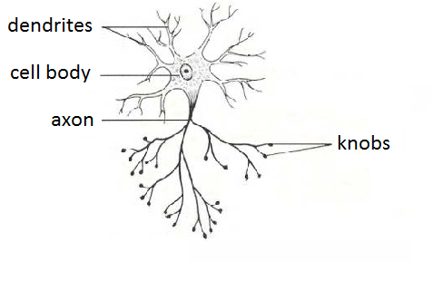

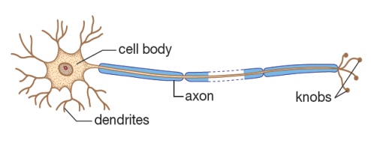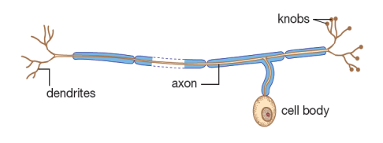

Name: **Connector** neurone

It: **joins** sensory neurones and motor neurones.

Name: **Motor** neurone

It: carries messages from

the CNS to effectors.

**Effectors** are:

muscles or glands

(tissues that secrete chemicals)

that put the messages into

effect

Name: **Sensory** neurone

It: carries messages from cells (in sense organs) to the brain and spinal cord.

sense organs: eyes, ears, tongue and skin

Cell body: part of the neurone that contains the **nucleus** (the control centre of the cell).

Dendrites: branches on the neurone that **receives messages** from other nerve cells

then it sends it on to the cell body.

Axon: branches that **sends nerve impulses** in only **one** direction—away from the cell body.

Knobs: parts at the **end** of the **axon** passes the **electrical message** on to the **next neurone**.

***Electrical messages***

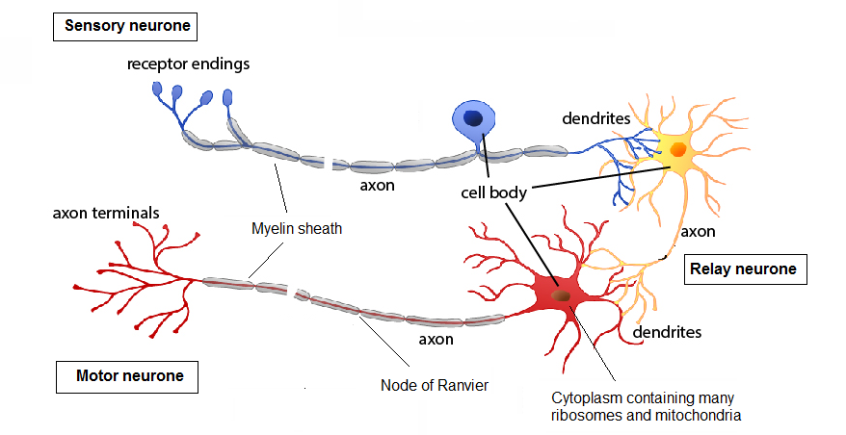

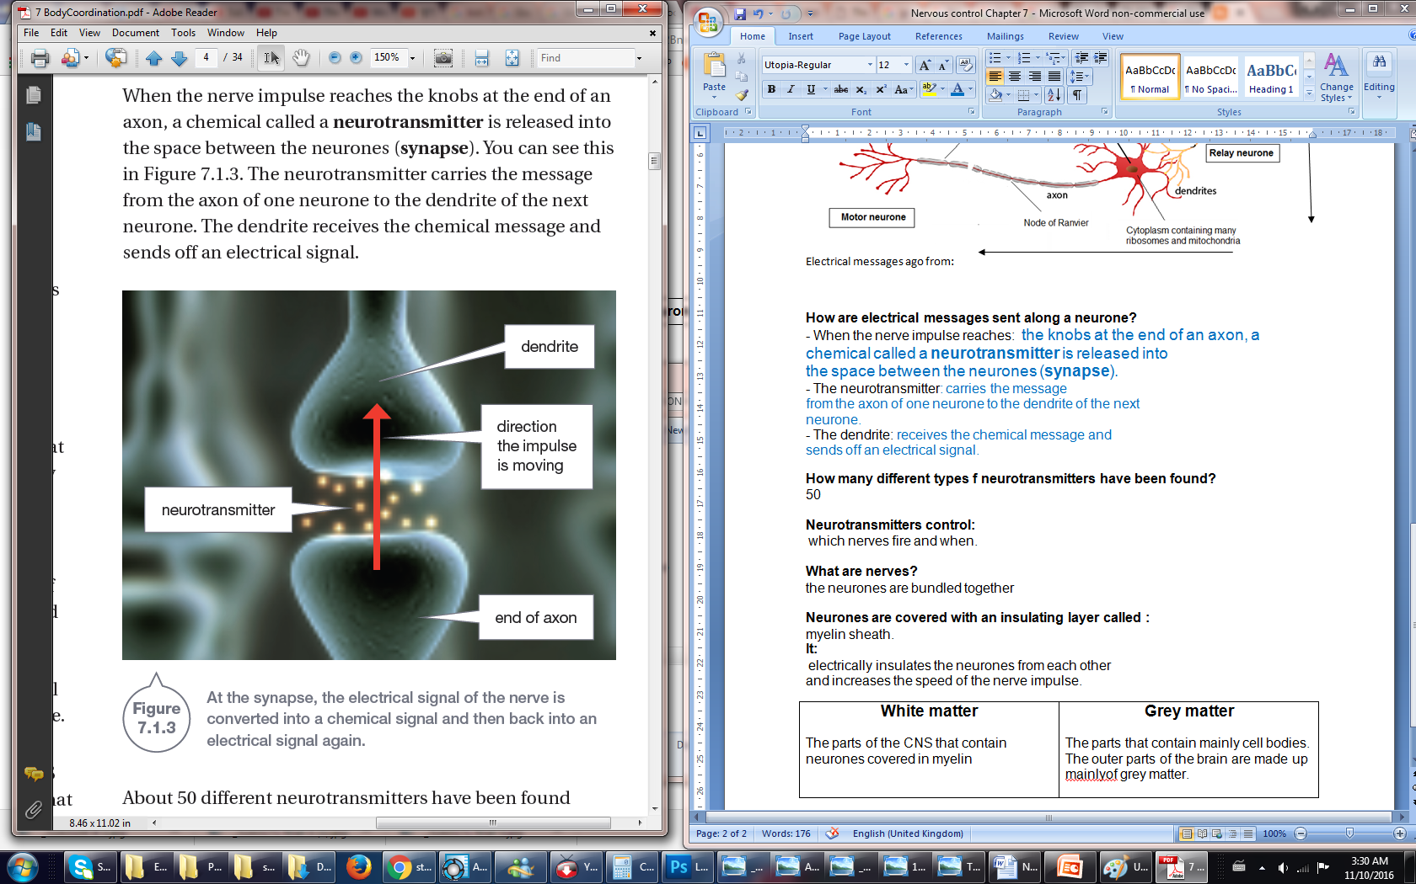

End of axon

dendrite

**Electrical messages go from:**

Axon (knobs)

Dendrites

How are electrical messages sent along a neurone?

*Complete the following sentences using* ***PEARSON 9*** *page* ***226***

- When the nerve impulse reaches: the knobs at the end of an axon, a **chemical** called a **neurotransmitter** is released into the space between the neurones (**synapse**).

- The neurotransmitter:

carries the message from the axon of one neurone to the dendrite of the next neurone.

- The dendrite:

receives the chemical message and sends off an electrical signal.

**Neurotransmitter:**

How many different types of neurotransmitters have been found?

50

Neurotransmitters control:

which nerves fire and when.

**Myelin sheath:**

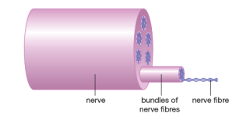**Definition:** an insulating layer covering the neurone.

Function: electrically insulates the neurones from each other and

increases the speed of the nerve impulse.

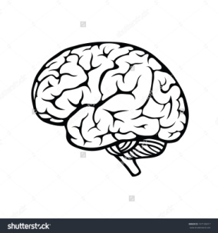

|  |  |
| --- | --- |
| **White matter**  -The parts of the CNS that contain neurones covered in myelin | **Grey matter**  - The parts that contain mainly cell bodies.  -The outer parts of the brain are made up mainly of grey matter. |